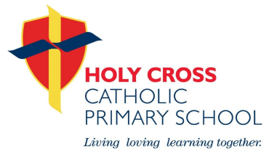Holy Cross Catholic Primary School
Prayer and Liturgy Policy

Chair of Governors | Steve McElroy
Headteacher | Helen Bannon
Date adopted: July 2025 | Review Date: July 2026

Holy Cross Catholic Primary School Mission Statement

A family living, loving and learning together through the light of Christ.

The context of this prayer and liturgy policy

The celebration of Catholic liturgies and prayers as an integral part of the learning and teaching should enable the school community to become reflective, experience the presence of God and should develop a mature spiritual life.’ (Marcus Stock (2012), Christ at the Centre, Catholic Truth Society, 23.)

Statement of requirement

The law requires all maintained Catholic schools to provide an act of daily collective worship (prayer and liturgy) for all pupils, including those in the sixth form (Section 70, 1988 Education Act) that is in accordance with the rites, practices, disciplines, and liturgical norms of the Catholic Church (School Standards and Framework Act 1998, schedule 20; 70 Instrument of Government, clause 2). Academies in England are required by their funding agreement and Articles of Association to comply with similar requirements (The Mainstream Academy and Free School: Supplemental Funding Agreement, December 2020; Model Articles for Catholic Academies, February 2019).

The law requires all maintained schools to recognise and respect that parents have the legal right to withdraw their children up to the age of 16 from prayer and liturgy (School Standards and Framework Act 1998, s.71(1A)). Sixth-form pupils can choose to withdraw themselves from prayer and liturgy (School Standards and Framework Act 1998, s.71(1B)).

The school’s provision for prayer and liturgy will fulfil pupils’ entitlement to experience the range of liturgical treasures of the Church, including a shared repertoire of prayers and liturgical music with which pupils in the school will be familiar.

Prayer and liturgy are not designated curriculum time. In the context of the Catholic school, this means that times of prayer and liturgy are not considered to be part of the allocation of curriculum time for Religious Education.

Responsibility

(a) Governance

The governors, as guardians of the Catholic school’s life and mission, have a responsibility to ensure that:
• prayer and liturgy are central to the Catholic life of the school and therefore are in line with the guidance set out by the Prayer and Liturgy Directory
• there is a named person(s) who is responsible for prayer and liturgy in the school (the Prayer and Liturgy Coordinator)
• the prayer and liturgy policy is updated regularly and shared with all stakeholders
• there is a budget for prayer and liturgy that reflects its centrality to the life of a
Catholic school.

(b) Headteacher

The headteacher, as the spiritual leader of the school as a Catholic community,
ensures that:
• prayer and liturgy are central to the Catholic life of the school and therefore are in line with the guidance set out by the Prayer and Liturgy Directory
• they work in partnership with the leader for prayer and liturgy
• those responsible for prayer and liturgy in the school have been given appropriate training and formation to ensure that all guidance is followed and adhered to
• there are suitable resources for prayer and liturgy in the school.

(c) Prayer and Liturgy Leader

Those responsible for prayer and liturgy ensure that:
• prayer and liturgy are central to the Catholic life of the school and therefore are in line with the guidance set out by the Prayer and Liturgy Directory
• there is an Annual Plan of Provision for prayer and liturgy across the school year which identifies liturgical seasons and key celebrations, as well as opportunities for the celebration of the Sacraments
• there is daily planned prayer for all pupils, appropriate to age and ability, as outlined in the Prayer and Liturgy Directory
• pupils are supported in their liturgical formation to take an active role in the planning, preparation and delivery of prayer and liturgy according to their age and capacity, and in a manner which facilitates their progressive participation
• resources to support the planning of prayer and liturgy are appropriate and readily available to staff and pupils
• induction on prayer and liturgy takes place for new members of staff as required
• staff have access to effective training and formation opportunities
• monitoring and evaluation of prayer and liturgy take place regularly and feed back into planning for future liturgies
• monitoring of prayer and liturgy is reported to the headteacher and governing body to support whole-school development and the Catholic life of the school
• there is collaboration with local clergy and parishes
• liaison with the Diocesan Advisory Service and others is maintained to ensure they keep updated with best practice.

Overview of prayer and liturgy provision

Prayer and Liturgy are central to daily life at our school and are carefully planned to provide regular, meaningful opportunities for all pupils and staff to pray, reflect and celebrate together as a school community.

Daily Prayer:

Every class begins the day with a morning prayer, offers prayer before lunch, and ends the day with a closing prayer.
Prayers are linked to the liturgical season, school mission, current RE branches and whole school projects such as Live Simply, Pilgrims of Hope.

Weekly Celebration of the Word:

Whole school Celebration of the Word takes place weekly, usually at the end of the week, focusing on the coming Sunday’s Gospel and its message.
Additional Key Stage or class-based liturgies are held throughout the week.
Opportunities for pupil-led prayer and liturgy take place regularly in classrooms, supported by teachers.

Celebration of Mass:

Whole school Mass is celebrated once per term, often to mark key liturgical events such as the start and end of the school year, significant feast days, and Holy Days of Obligation.
Year groups and classes also attend smaller Masses or services with the parish priest throughout the year, either in school or at the parish church.
Pupils are encouraged to actively participate through readings, prayers of intercession, offertory and music.

Sacrament of Reconciliation:

During Advent and Lent, Key Stage 2 pupils are given the opportunity to receive the Sacrament of Reconciliation, supported by the parish priest.
Preparation for the sacrament takes place in special session, within RE lessons and prayer and liturgy.

Seasonal and Special Liturgies:

The school marks significant moments in the liturgical calendar with special liturgies, including:

* Advent and Christmas services (e.g., Nativity, Carol Service)
* Lenten liturgies and reflections
* Holy Week services (e.g., Stations of the Cross)
* Easter celebrations
* Pentecost service and celebrations
* Year 6 Leavers’ Liturgy
* These provide opportunities for reflection, prayer, and celebration as a school community.

This planned provision ensures that all children have regular and varied opportunities to experience and participate in the liturgical and prayer life of the school.

Further detail can be found about this provision in the Prayer and Liturgy calendar of Events.

Resourcing

Prayer and liturgy are central to the school’s understanding of itself as a Catholic school, and this is reflected in the annual budget allocation and available resources, including staff time, chaplaincy provision and dedicated spaces for prayer and liturgy. The Catholic character of the school is reflected in religious artefacts and images on display throughout the building. Dedicated spaces for prayer and liturgy are furnished and maintained as such, and updated to reflect the Church’s liturgical season. Staff training and formation
costs are funded separately to ensure that all staff are able to fulfil their responsibility to contribute to the prayer and liturgical life of the school. Resources and prayers are found on the school’s shared drive.

Training and formation

All new staff are supported during induction and beyond, so that they fully understand the responsibility they carry within their individual role for leading prayer and liturgy in the school. Any individual training needs are identified and addressed through training and formation. There is also the opportunity for whole-staff professional development at least once a year, so that all staff understand the importance of prayer and liturgy and relevant staff are well supported to lead as required.

Monitoring and evaluation

Monitoring and evaluation of the quality and impact of prayer and liturgy takes place regularly, and at least annually, and involves all key stakeholders: pupils, parents, staff, clergy and governors. Areas for development are identified and issues raised are actioned and evidenced as appropriate.

Review

The policy will be reviewed as part of the regular cycle of policy review conducted by the governors.

Common Prayers (Section 7-Prayer and Liturgy: To Love You More Dearly)

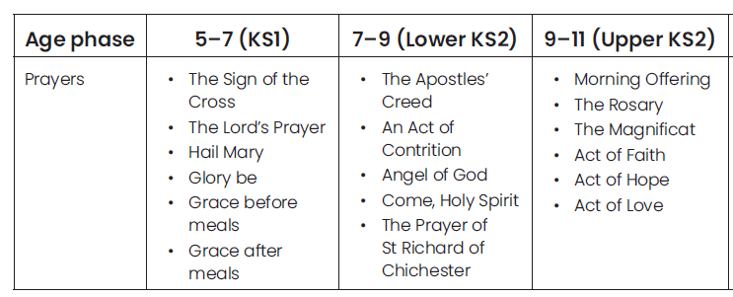
(In addition to the Common Prayers, our children celebrate through prayer our Holy Cross School Prayer and our Holy Cross Grace Before Meals prayer)

