Number and Place value
- Ali puts these five numbers in their correct places on a number line.

511 499 502 555 455
Write the number closest to 500
Write the number furthest from 500

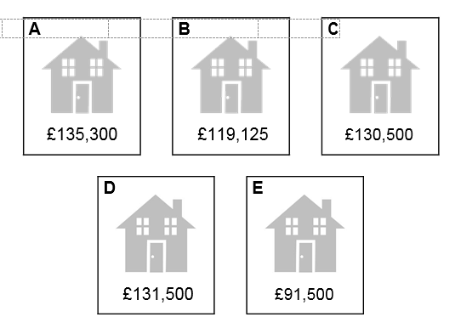
- Put these houses in order of price starting with the lowest price.

One has been done for you.

B

lowest

- Write the number that is five less than ten million.

- Write the number that is one hundred thousand less than six million.

- Write each number in its correct place on the diagram.

16 17 18 19

prime numbers | square numbers
 | even
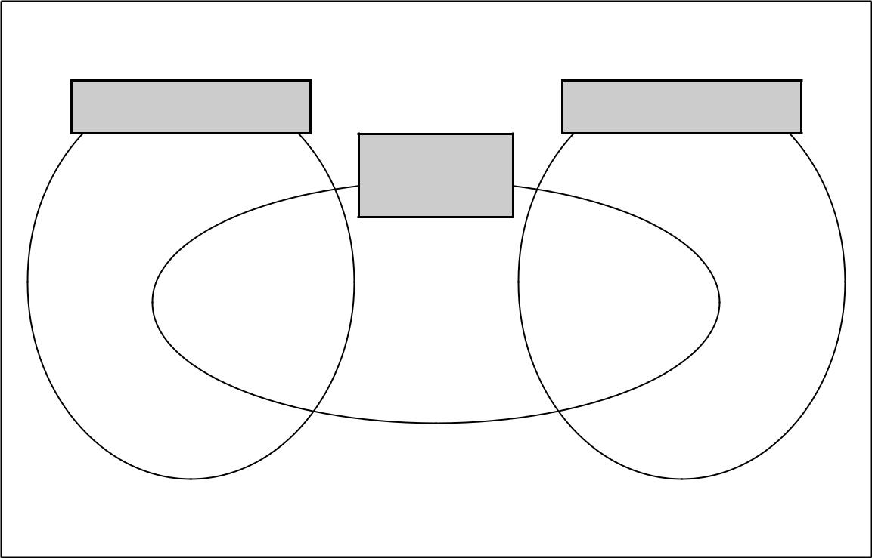 | numbers

- This table shows the temperature at 9am on three days in January.

1st January | 8th January | 15th January
+ 5°C | – 4°C | + 1°C

What is the difference between the temperature on 1st January and the temperature on 8th January?

On 22nd January the temperature was 7 degrees lower than on 15th January.
What was the temperature on 22nd January?

- Complete this table by rounding the numbers to the nearest hundred.
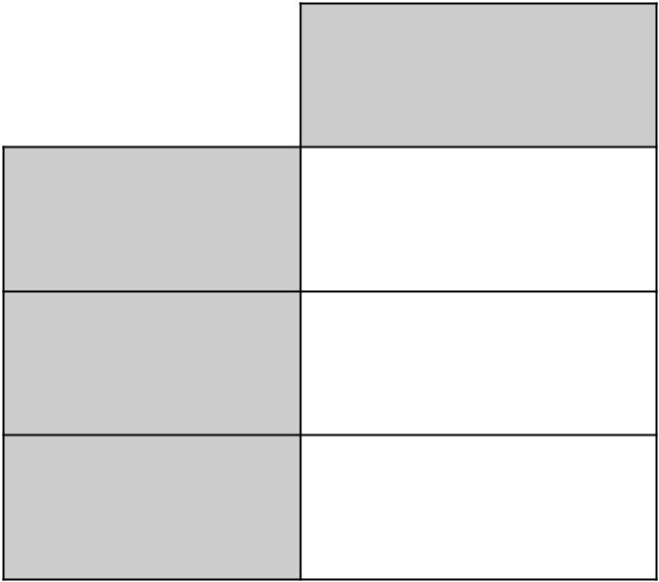
Rounded to the
nearest hundred
20,906

2,090.6

209.06

- Circle two numbers that multiply together to equal 1 million.
- 2,000 5,000 50,000

Number | 1,000 more
3,500 | 4,500
85
 | 9,099
 | 15,250
- Complete this table with the missing numbers. One row has been done for you.

- Round 84 ,516

to the nearest 10

to the nearest 100

to the nearest 1,000


- At the end of a film, the year is given in Roman numerals.

Write the year MMVI in figures.

- Dev thinks of a whole number. He multiplies it by 4
He rounds his answer to the nearest 10. The result is 50. Write all the possible numbers that Dev could have started with.

Calculations

- Write the three missing digits to make this addition correct.
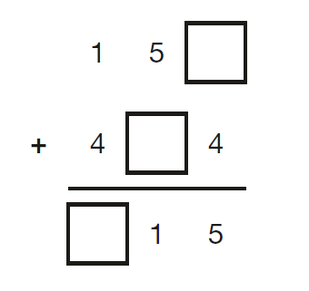

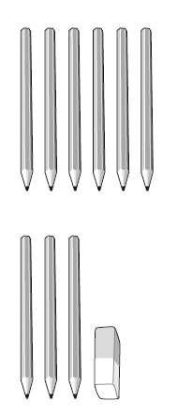
- 6 pencils cost £1.68

3 pencils and 1 rubber cost £1.09

What is the cost of 1 rubber?

- Write all the common multiples of 3 and 8 that are less than 50

- Write the missing number.

70 ÷ | 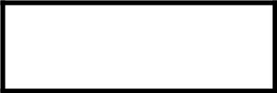  = 3.5

- Miss Mills is making jam to sell at the school fair. Strawberries cost £7.50 per kg.
Sugar costs 79p per kg.
10 glass jars cost £6.90
She uses 12 kg of strawberries and 10 kg of sugar to make 20 jars full of jam.
Calculate the total cost to make 20 jars full of jam.

- The numbers in this sequence increase by 14 each time. Write the missing numbers
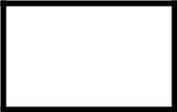
82 | 96 | 124 | 138

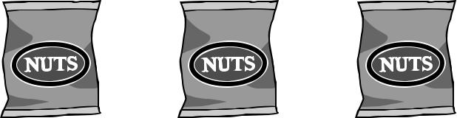
- Olivia buys three packets of nuts.
She pays with a £2 coin. This is her change.
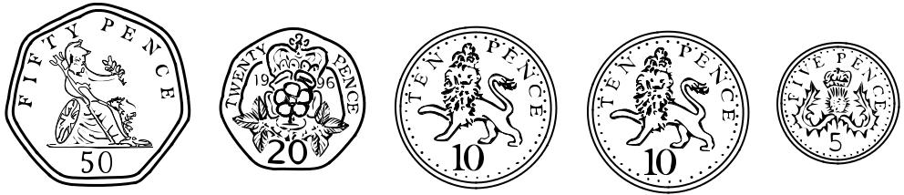

What is the cost of one packet of nuts?

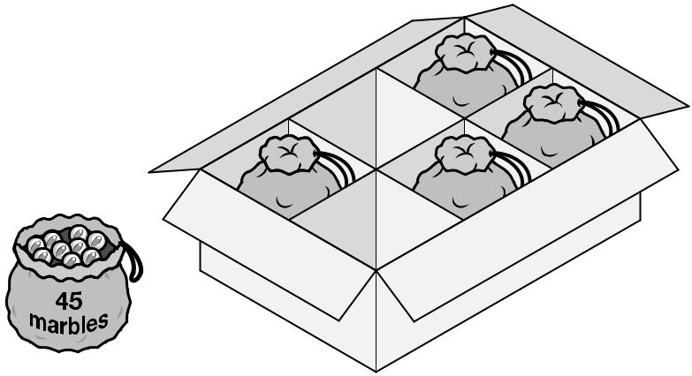
- A toy shop orders 11 boxes of marbles.
Each box contains 6 bags of marbles.
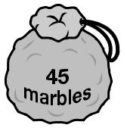
Each bag contains 45 marbles. How many marbles does the shop order in total?

- 5,542 ÷ 17 = 326
Explain how you can use this fact to find the answer to 18 × 326

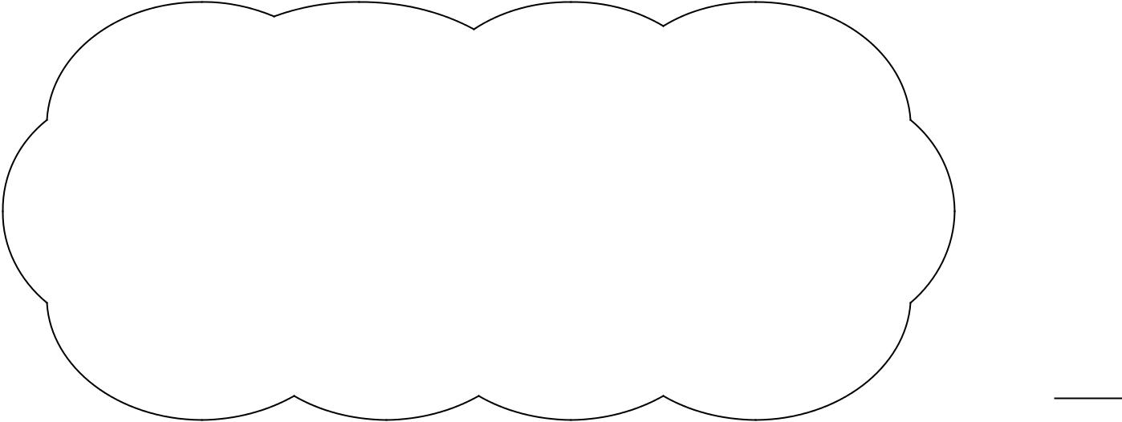

- Circle the number that is 10 times greater than nine hundred and seven.

9,700 907 9,007 970 9,070

- At the start of June, there were 1,793 toy cars in the shop.
During June, 8,728 more toy cars were delivered
9,473 toy cars were sold.
How many toy cars were left in the shop at the end of June?

- Amina posts three large letters.
The postage costs the same for each letter. She pays with a £ 20 note.
Her change is £14.96
What is the cost of posting one letter?

- Write the missing numbers to make this multiplication grid correct.

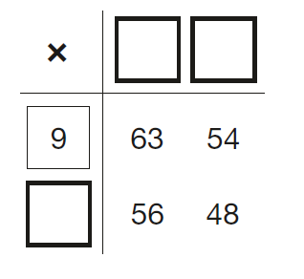

- This table shows the heights of three mountains.

Mountain | Height in metres
Mount Everest | 8,848
Mount Kilimanjaro | 5,895
Ben Nevis | 1,344

How much higher is Mount Everest than the combined height of the other two mountains?

- Write the missing number to make this division correct.

75 ÷ | = 7.5

- A group of friends earns £80 by washing cars. They share the money equally.
They get £16 each. How many friends are in the group?

- Chen uses these digit cards.

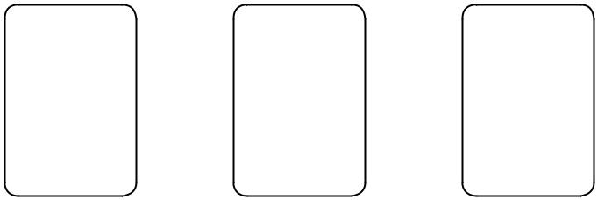

5 6 9

She makes a 2-digit number and a 1-digit number.
She multiplies them together.
Her answer is a multiple of 10
What could Chen’s multiplication be?
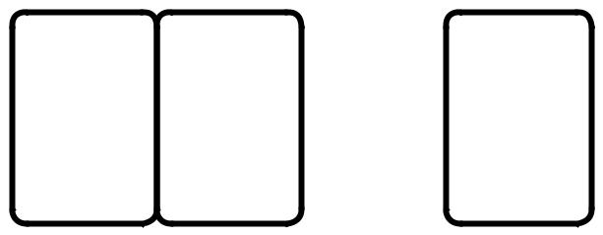

×

- Write three factors of 30 that are not factors of 15

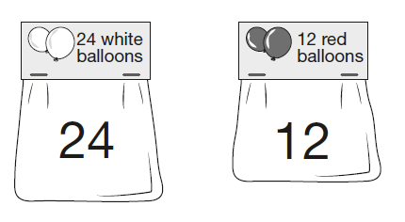
- Adam buys 6 bags of white balloons.
Chen buys 3 bags of red balloons.

Adam says,
‘I have four times as many balloons as Chen.’
Explain why Adam is correct.

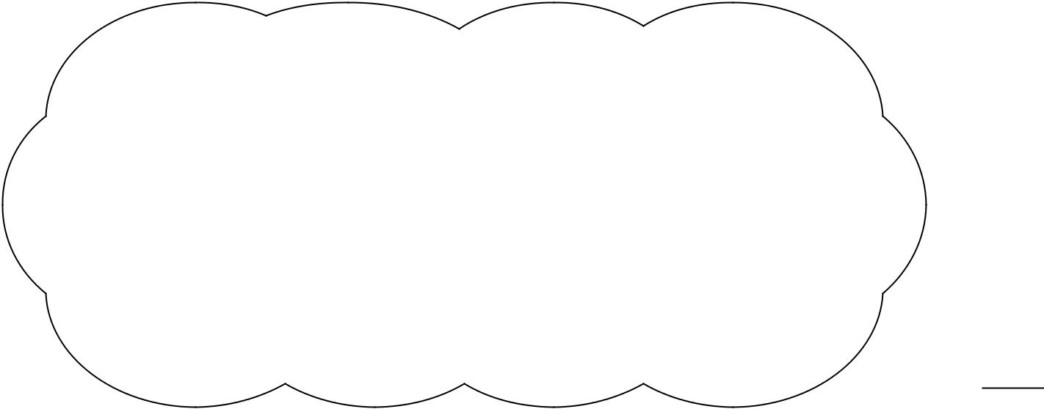

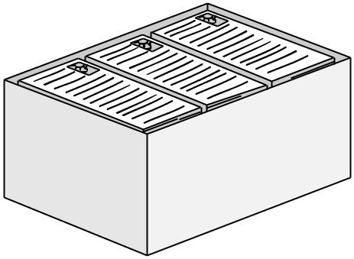
- There are 2,400 leaflets in a box.
William and Ally take 450 leaflets each.
Adam and Chen share the rest of the leaflets equally.
How many leaflets does Adam get?

- A square number and a prime number have a total of 22
What are the two numbers?

 | + |  | = 22
square |  | prime
number |  | number

Fractions, Decimals and Percentages

- Write the two missing values to make these equivalent fractions correct.

8 4
= =

3 12

- Circle two numbers that add together to equal 0.25

0.05 0.23 0.2 0.5

- Each diagram below is divided into equal sections. Shade three-quarters of each diagram.
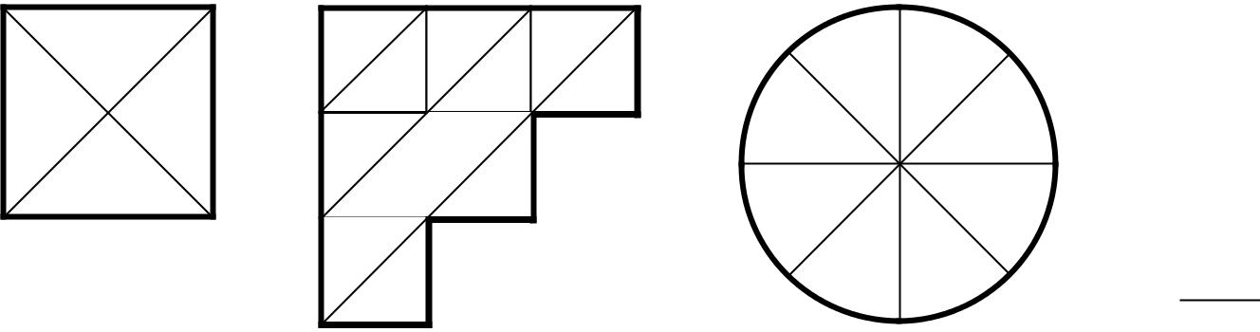

- Write these numbers in order, starting with the smallest.
0.78 0.607 5.6 0.098 4.003

smallest

- Jacob cuts 4 metres of ribbon into three pieces. The length of the first piece is 1.28 metres. The length of the second piece is 1.65 metres. Work out the length of the third piece.

- Lara chooses a number less than 20 She divides it by 2 and then adds 6 She then divides this result by 3 Her answer is 4.5. What was the number she started with?

- Lara had some money. She spent £1.25 on a drink.
She spent £1.60 on a sandwich.
She has three-quarters of her money left.
How much money did Lara have to start with?

- Write these numbers in order of size, starting with the smallest.

1.9 0.96 1.253 0.328

smallest

- Tick two shapes that have ¾ shaded
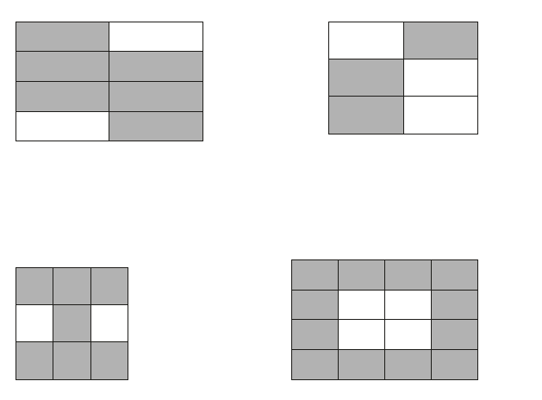
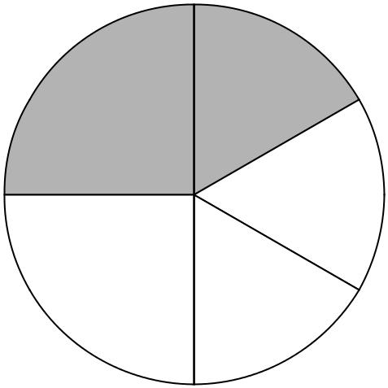
- In this circle, ¹₄ and ¹₆ are shaded

What fraction of the whole circle is not shaded?

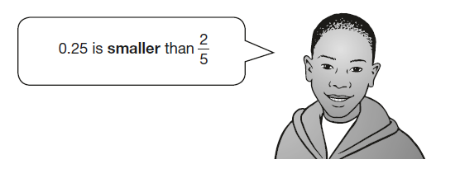
- Adam says,

Explain why he is correct.

- In each box, circle the number that is greater.
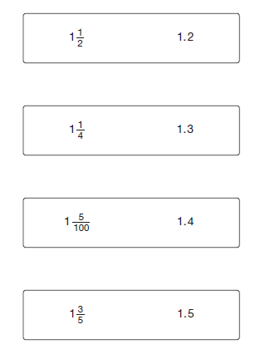
- The numbers in this sequence increase by the same amount each time. Write the missing numbers.
 | 1 | 1 ⁵/₈ | 2 ¹/₄

Ratio and Proportion
- 6 small bricks have the same mass as 5 large bricks.
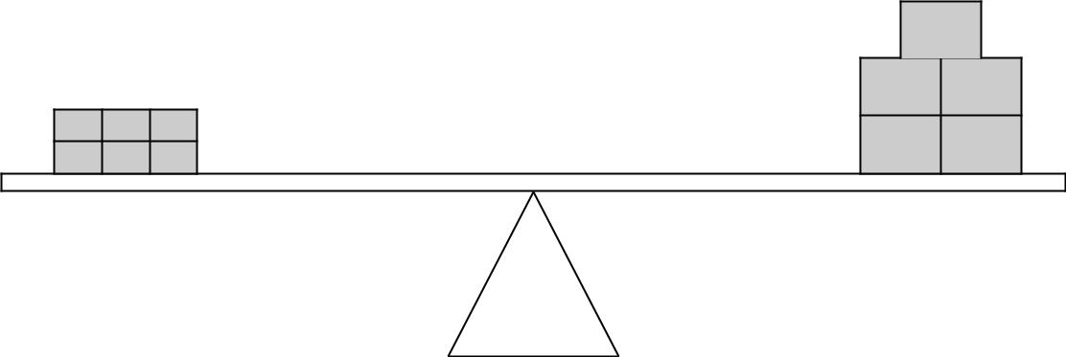

The mass of one small brick is 2.5 kg.
What is the mass of one large brick?

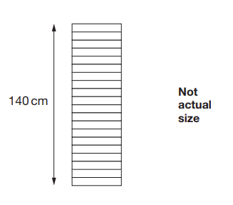
- A stack of 20 identical boxes is 140 cm tall.

Stefan takes three boxes off the top.

How tall is the stack now?

- Amina planted some seeds. For every 3 seeds Amina planted, only 2 seeds grew. Altogether, 12 seeds grew.
How many seeds did Amina plant?

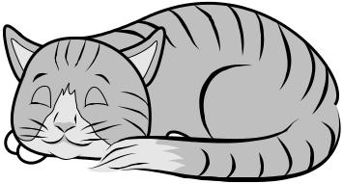
- A cat sleeps for 12 hours each day.
50% of its life is spent asleep.

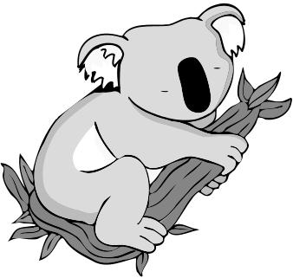
Write the missing percentage.
A koala sleeps for 18 hours each day.

% of its life is spent asleep.

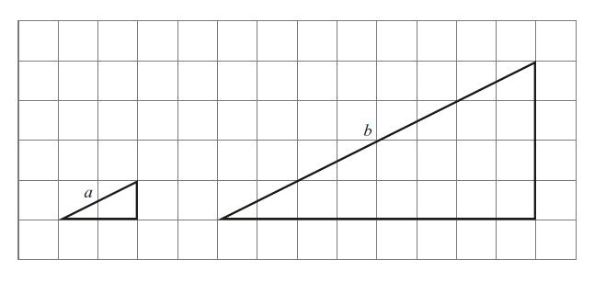
- Here are two similar right-angled triangles.

- Write the ratio of side a to side b.

a : b = | :
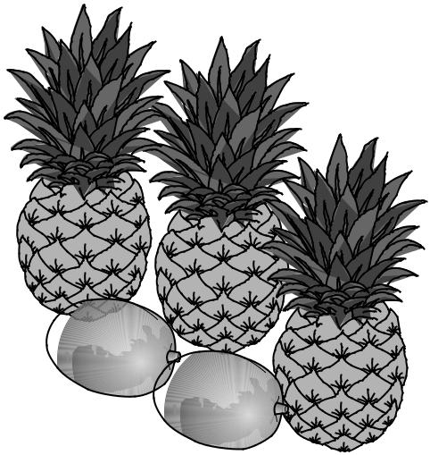
- 3 pineapples cost the same as 2 mangoes.
One mango costs £1.35
How much does one pineapple cost?

Algebra
- n = 22
What is 2n + 9?

- 2q + 4 = 100
- Work out the value of q.

- Each shape stands for a number.
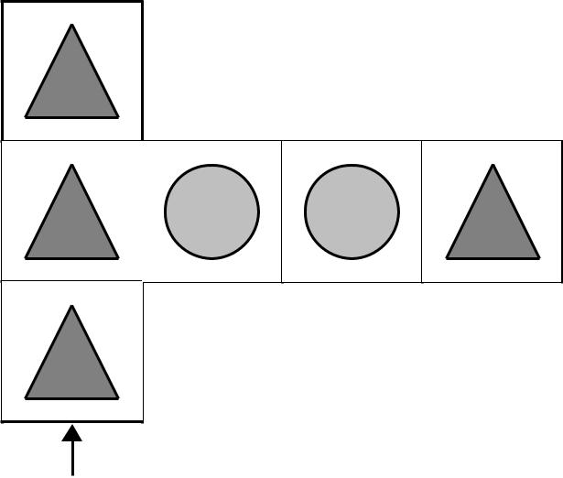

Total 100

Total 96
Work out the value of each shape.

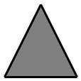 =

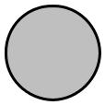 =

- Here is a rule for the time it takes to cook a chicken.

Cooking time = 20 minutes plus an extra
40 minutes for each kilogram
How many minutes will it take to cook a 3 kg chicken?
What is the mass of a chicken that takes 100 minutes to cook?

- In this diagram, the shaded rectangles are all of equal width (w).
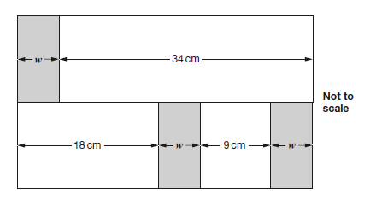
Calculate the width (w) of one shaded rectangle.

a | b
17 | 9
18 | 19
19 | 29
20 | 39
- Here is a pattern of number pairs.
Complete the rule for the number pattern.

b = | × a –

Measures
- A packet contains 1.5 kg of oats.
Every day Maria uses 50 g of oats to make porridge.
How many days does the packet of oats last?

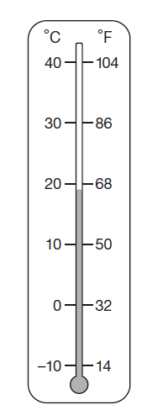
- This thermometer shows temperatures in both °C and °F.
Work out what 25 °C is in °F.

- A clock shows this time twice a day.
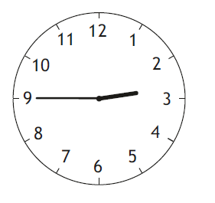

Tick the two digital clocks that show this time.
03:45 |  | 02:45 |  | 09:45

21:45 14:45

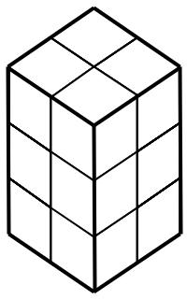
- Emma makes a cuboid using 12 cubes

Write the letter of the cuboid that has a different volume from Emma’s cuboid.

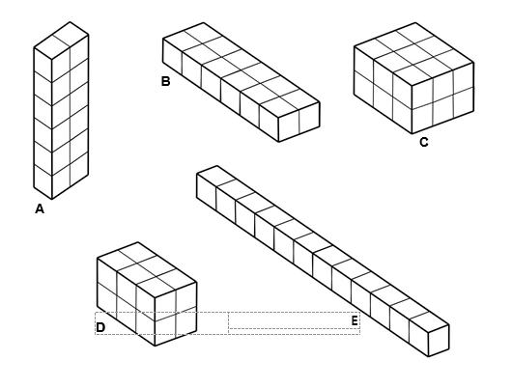

- Complete each sentence using a number from the list below.

120 240 600 1,440 3,600 6,000

There are | seconds in an hour.

There are | minutes in a day.

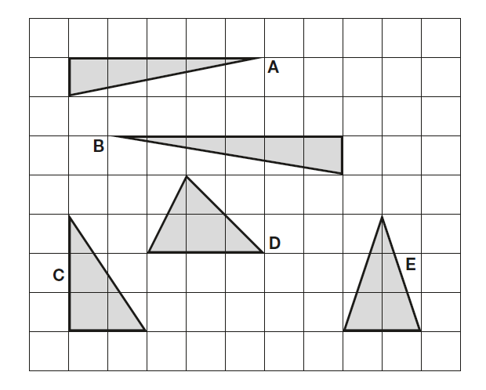
- Here are five triangles on a square grid.

Four of the triangles have the same area.

Which triangle has a different area?

- Write the missing numbers.

60 months = |  | years
72 hours = |  | days
84 days = |  | weeks

- Ally and Jack buy some stickers.
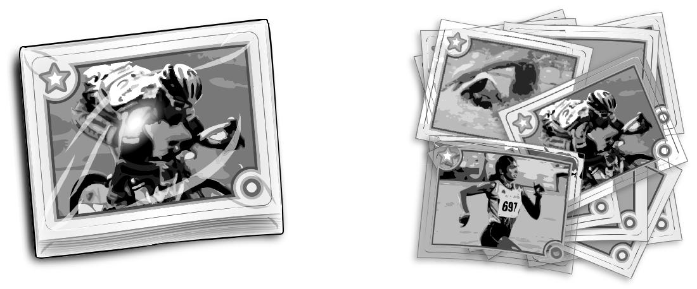

Pack of 12 stickers 12 stickers

£10.49 99p each

Ally buys a pack of 12 stickers for £10.49
Jack buys 12 single stickers for 99p each.
How much more does Jack pay than Ally?

- On a map, 1cm represents 20 km.
20 40 60 80 100 km

The distance between two cities is 250 km.
On the map, what is the distance between the two cities?

- The children at Farmfield School are collecting money for charity. Their target is to collect £360.
So far they have collected £57.73
How much more money do they need to reach their target?

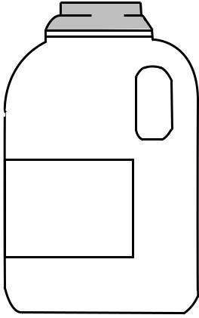
- A bottle contains 568 millilitres of milk. Jack pours out half a litre.

Milk
How much milk is left?

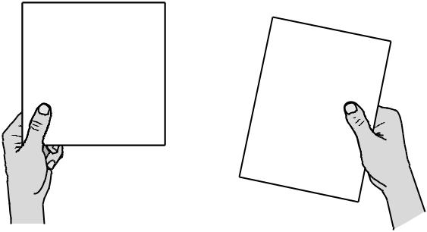
- A square tile measures 20 cm by 20 cm.

A rectangular tile is 3 cm longer and 2 cm narrower than the square tile.

What is the difference in area between the two tiles?

- Cube A and cuboid B have the same volume.

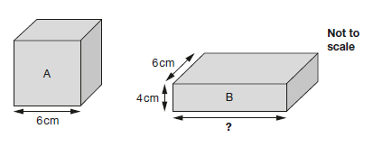

Calculate the missing length on cuboid B.
Geometry - Shape
- Calculate the size of angles a and b in this diagram.
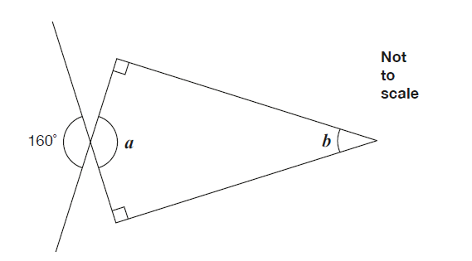

- Here are five angles marked on a grid of squares.
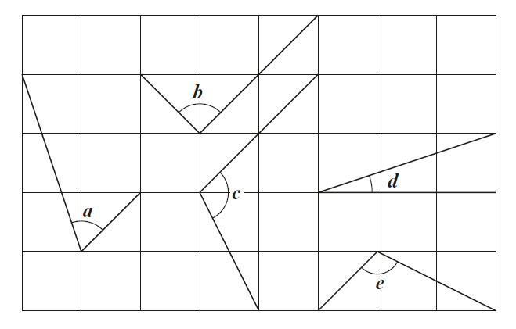
Write the letters of the angles that are obtuse
Write the letters of the angles that are acute.

- The diagonals of this quadrilateral cross at right angles.
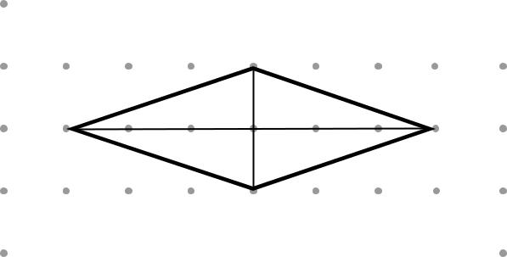

- Tick all the quadrilaterals that have diagonals which cross at right angles.
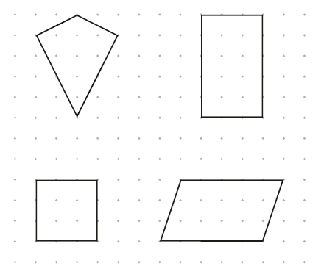

- Here are diagrams of some 3-D shapes.
Tick each shape that has the same number of faces as vertices.
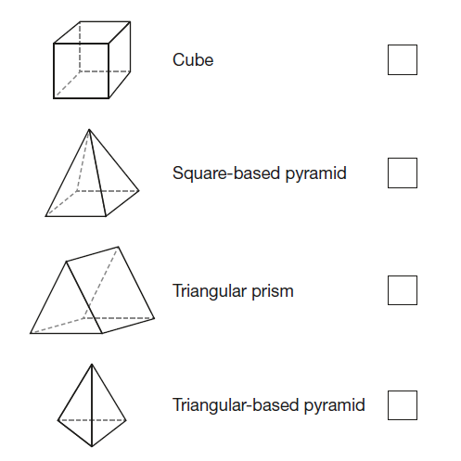

- A bicycle wheel has a diameter of 64 cm. What is the radius of the bicycle wheel?

- Layla completes one-and-a-half somersaults in a dive.
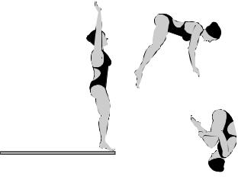

start
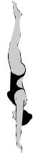
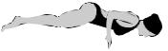



How many degrees does Layla turn through in her dive?

- Look at the letters below.
Circle the letter below that has both parallel and perpendicular lines.
A C E L Z

- Circle the pentagon with exactly four acute angles
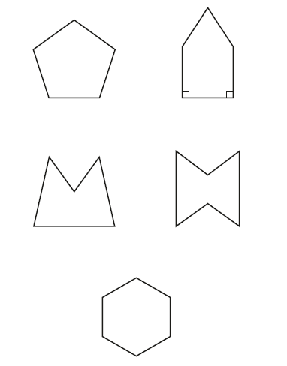
Geometry - Position and Direction

- This diagram shows a shaded shape inside a border of squares. Draw the reflection of the shape in the mirror line. Use a ruler.
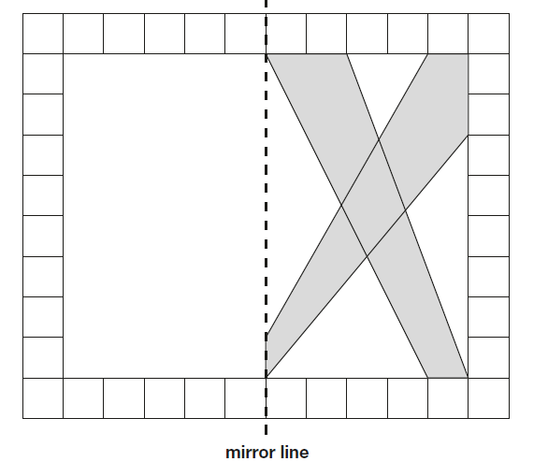
- Here are two triangles drawn on coordinate axes.
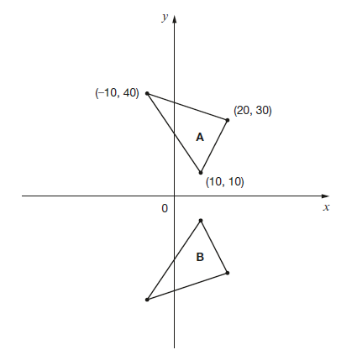
Triangle B is a reflection of triangle A in the x-axis.

Two of the new vertices of triangle B are (10, –10) and (20, –30).

What are the coordinates of the third vertex of triangle B?

- A triangle is translated from position A to position B.

A
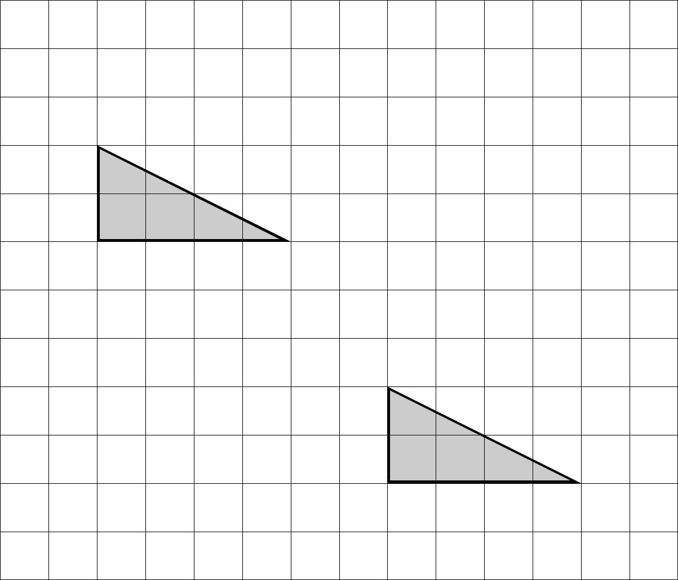

B

Complete the sentence.
The triangle has moved |  | squares to the right
and |  | squares down.


- The vertices of a quadrilateral have these coordinates.
(1, 5) (5, 4) (1, −3) (−3, 4)

One side of the quadrilateral has been drawn on the grid.
Complete the quadrilateral. Use a ruler.
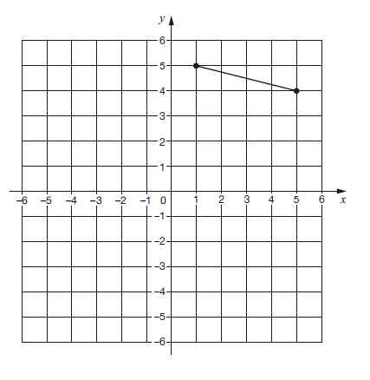

- Here is a triangle drawn on a coordinate grid.
The triangle is translated 7 right and 5 up. Draw the triangle in its new position.

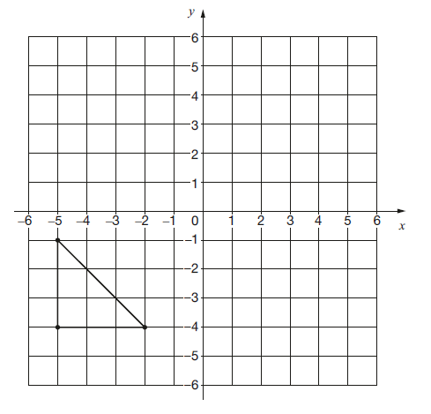
Statistics
- This table shows the number of people living in various towns in England.

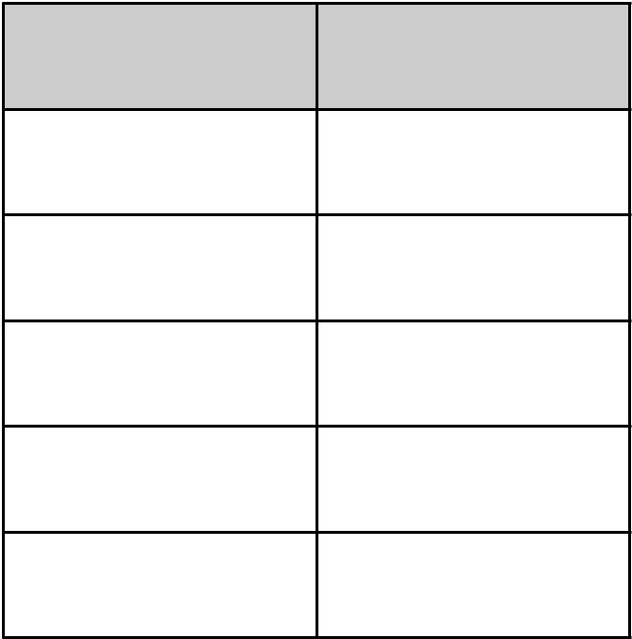
Town Population

Bedford 82,448

Carlton 48,493
Dover 34,087

Formby 24,478

Telford 166,640

What is the total of the numbers of people living in Formby and in Telford?

What is the difference between the numbers of people living in Bedford and in Dover?

- Here is part of the bus timetable from Riverdale to Mott Haven.

Riverdale | 10:02 | 10:12 | 10:31 | 10:48
Kingsbridge | 10:11 | 10:21 | 10:38 | 10:55
Fordham | 10:28 | 10:38 | 10:54 | 11:11
Tremont | 10:36 | 10:44 | 11:00 | 11:17
Mott Haven | 10:53 | 11:01 | 11:17 | 11:34

How many minutes does it take the 10:31 bus from Riverdale to reach Mott Haven?

Mr Evans is at Fordham at 10:30. What is the earliest time he can reach Tremont on the bus?

- William asks the children in Year 2 and Year 6 if they walk to school. This graph shows the results.
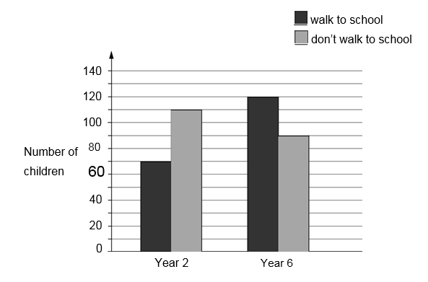
Altogether, how many children don’t walk to school?
How many more Year 6 children than Year 2 children walk to school?

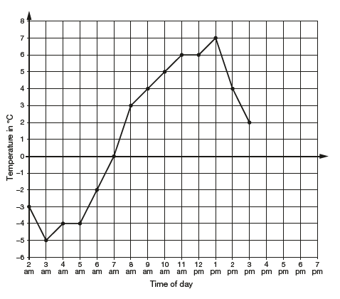
- This graph shows the temperature in °C from 2 am to 3 pm on a cold day.

How many degrees warmer was it at 3 pm than at 3 am?

At 6 pm the temperature was 4 degrees lower than at 3 pm. What was the temperature at 6 pm?

- Here is the morning timetable for Chen’s class this week.

Time | Mon | Tue | Wed | Thu | Fri
9:00 am–10:30 am | Maths | English | Maths | English | Maths
10:30 am–11:00 am | Break | Break | Break | Break | Break
11:00 am–12:00 pm | English | Maths | Science | Maths | English

What is the total number of hours for English on this timetable?

- William wants to travel to Paris by train. He needs to arrive in Paris by 5:30 pm. Circle the latest time that William can leave London.

Leaves London | Arrives Paris
12:01 | 15:22
12:25 | 15:56
13:31 | 16:53
14:01 | 17:26
14:31 | 17:53
15:31 | 18:53
16:01 | 19:20

