Number and Place value
- I am counting forwards. When I stop counting, tick the next number I should say: ninety-seven, ninety-eight, ninety-nine, one hundred …

- Write down all the odd numbers between twenty and thirty.

- Listen to the number sequence. Zero, three, six, nine… Write the next two numbers in the sequence.

- What number is one less than twenty-four?

- How many tens are there in ninety-six?

- Write the correct number in each box.
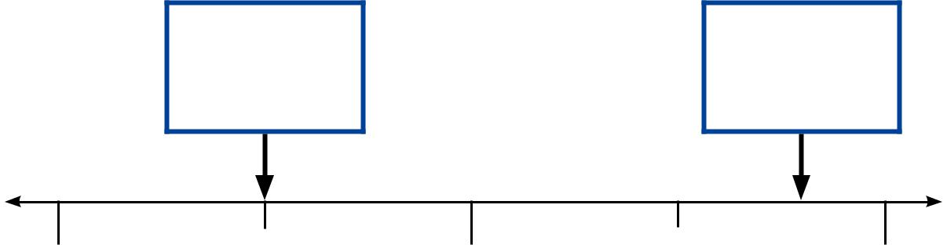

40 50 60

- Write these numbers in order, starting with the smallest.

73 37 76 36 63

smallest largest

- Circle the two numbers that are even.

73 58

64 45

- Look at these numbers.

0 | 14 | 50 | 61

- Write each number once to make these correct.

>

>

- Here are some signs.

> < =

Write the correct sign in each box.
10 + 5 |  | 10 × 5

2 × 6 |  | 6 + 6

- Fill in the missing numbers to make each pair of cards total 17 One pair is done for you.
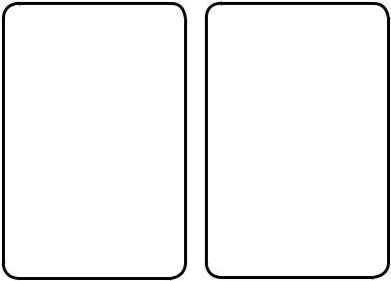

10 7
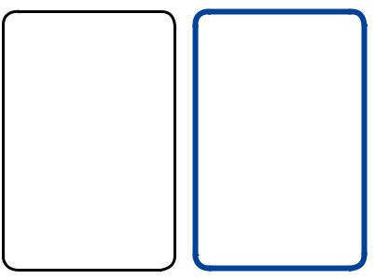

9
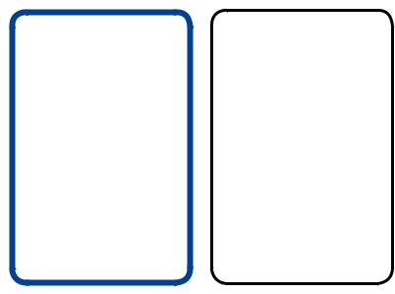

6

- On these cards, the word should match the number. One of these cards is wrong. Draw a cross on the card that is wrong.
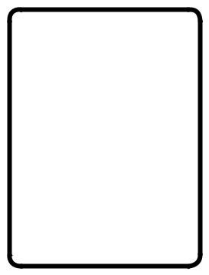

15
fifteen 19
ninety
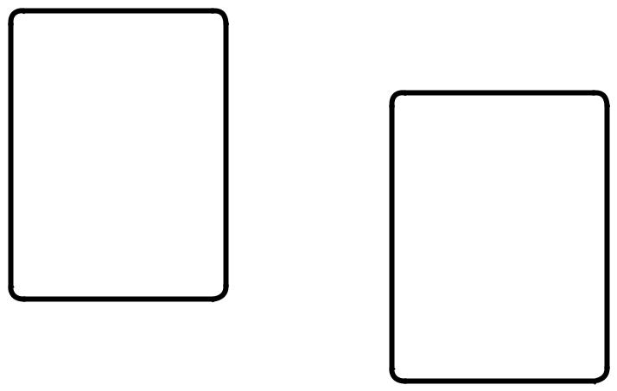

49
forty-nine 51
fifty-one

- The numbers on this number line go up by the same amount each time. Write the missing numbers in the boxes.
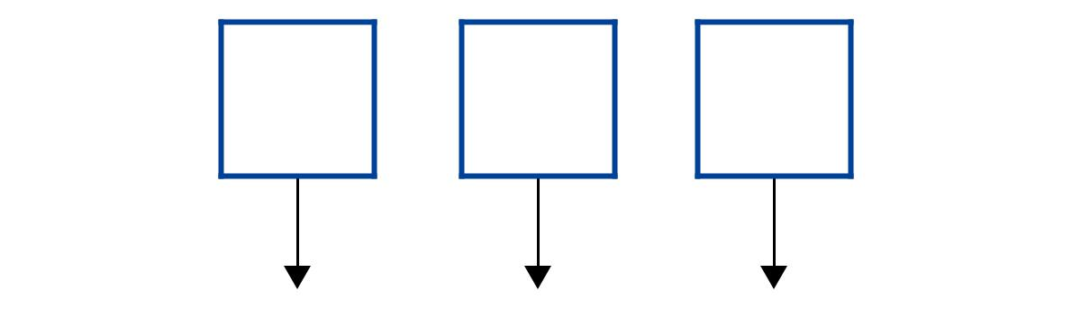

20 |  | 40

- Circle the correct number of tens and ones to make sixty-three.

10 | 10 |  | 1 | 1
10 | 10 | 1 |  | 1
10 | 10 |  |  | 1
 | 10 |  | 1 | 1
10 | 10 |  |  | 1
10 | 10 |  |  | 1

Addition and Subtraction
- Ajay has four friends: Ben, Kemi, Sam and Sita. He gives ten pence to each friend. How much money does he give altogether?

- There are sixty-three bean bags in a sack. Amy takes ten bean bags away. How many bean bags are left in the sack?
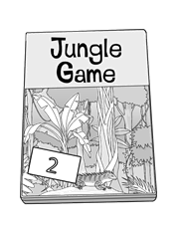
- A game costs £25. Ben has £19. How much more money does Ben need to buy the game?

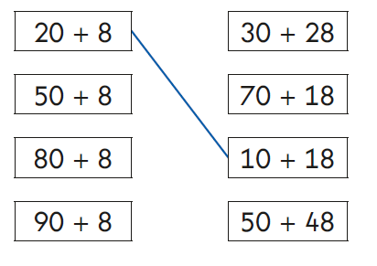
- Match the sums that have the same answer. One is done for you.

- Ben has 75 cherries. He eats 28 of them. How many cherries does he have left?

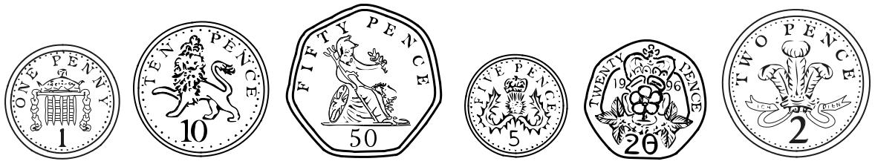
- Look at these coins:

What is the largest amount you can make using three of these coins?

- Write six different numbers to make these sums correct.

+ |  | = 27

+ |  | = 27

+ |  | = 27

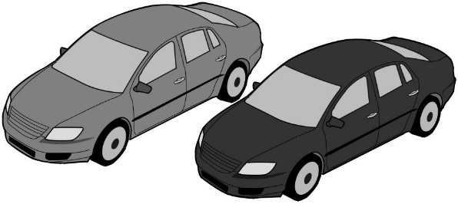
- Ben and Sita count cars.
Ben counts 38 red cars.
Sita counts 23 blue cars.
How many cars do they count altogether?

- Write the missing number to make this number sentence correct.
9 + 7 - |  | = 12

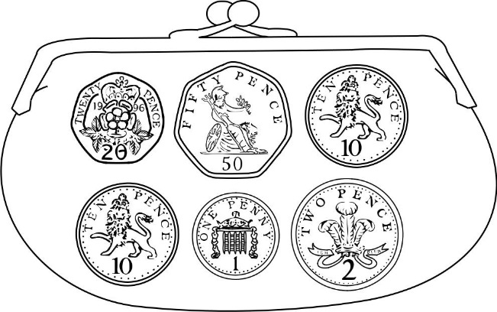
- Sita has these coins in her purse.
How much money does she have?

- Complete these sums. One is done for you.

3 + 7 = 10

 | + |  | =
33 | + |  | = | 40

+ 7 = 80

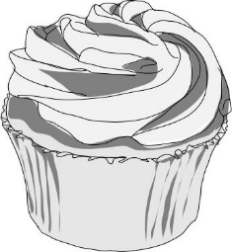
- There are 55 cakes.
20 boys and 19 girls each take a cake.
How many cakes are left?

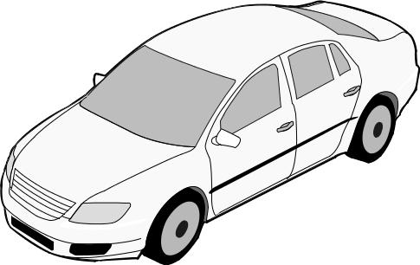
- There are 76 cars in the car park.
18 more cars go into the car park.
Then 35 cars go out.
How many cars are in the car park now?
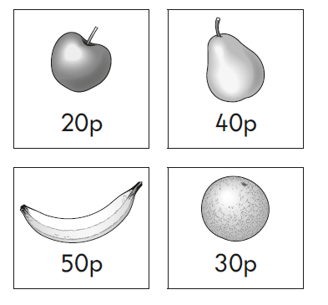
- Look at these four fruits.
Kemi buys three different fruits.
She spends exactly £1.
Tick the three fruits that she buys.

- There are eleven girls and twelve boys in a class. How many children are there in total?

- Three numbers add up to fifty-seven. The first number is forty. The second number is seven. What is the third number?

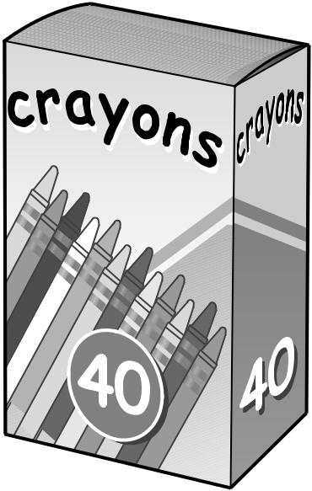
- There are 40 crayons in a box.
Sam takes 17 crayons.
Kemi takes 10 crayons.
How many crayons are left?

- There are 20 balloons. 7 balloons fly away. How many balloons are left?

- Amy has 21 counters altogether. She has 14 counters in one hand.
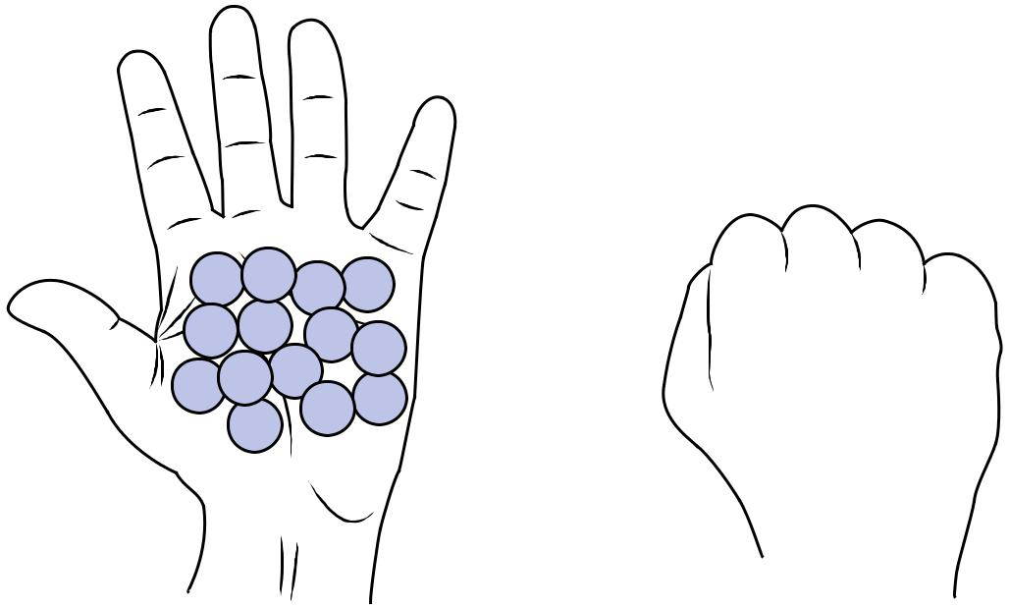

How many counters does she have in the other hand?

- How many shells does Amy have?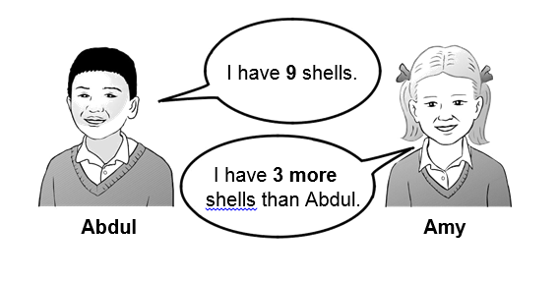
- Write two numbers to make this calculation correct.

+ |  | = 19

Now write three numbers to make this calculation correct.

+ |  | + |  | = 19

Multiplication and Division

- Ajay, Sam and Kemi have 4 conkers each.
How many conkers do they have altogether?

- Look at the array of circles.

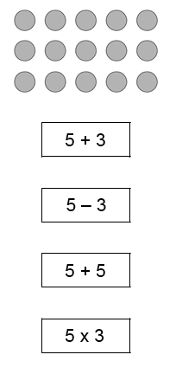
Now look at the four calculations.
Tick the calculation that describes the array.

- One length of a swimming pool is 10 metres.
Abdul swims the length of the pool 4 times.
Abdul works out how many metres he swims altogether.
Circle the two calculations that Abdul can use.

- + 4

4 × 10

10 + 10 + 10 + 10

- + 4 + 4 + 4

- 20 bananas are shared equally among 4 monkeys. How many bananas does each monkey get?

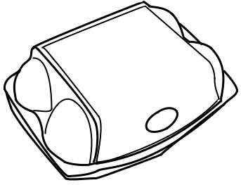
- Ben has 4 boxes of eggs.
6 eggs

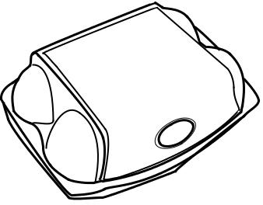
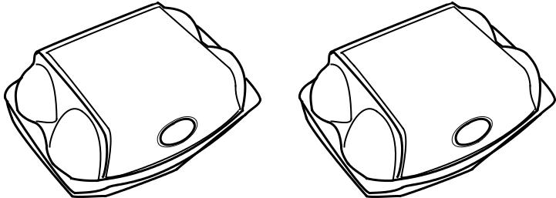
6 eggs
6 eggs
6 eggs

Write a number sentence using × and = to show that Ben has 24 eggs altogether.

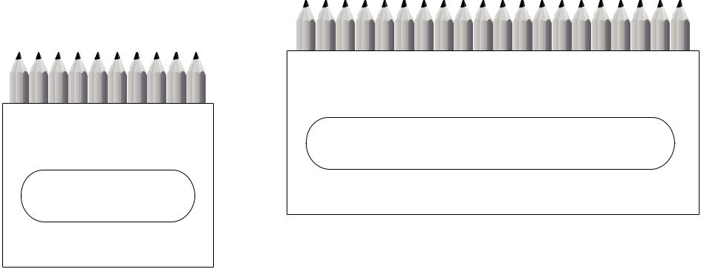

20 pencils

10 pencils


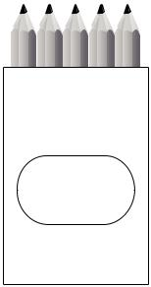
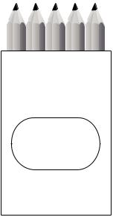

5 pencils

5 pencils

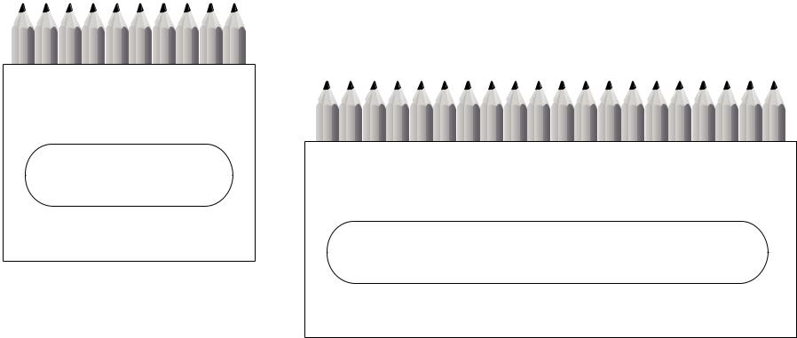

10 pencils
20 pencils

- Kemi and Ben share these pencils equally.
How many pencils do they each get?

- Miss Smith needs 30 apples for her class.
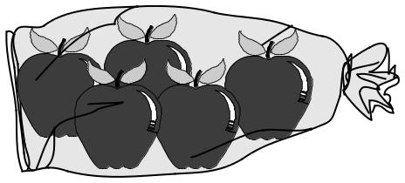
There are 5 apples in each bag.

How many bags of apples does Miss Smith need altogether?

Fractions

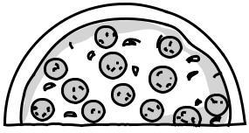
- Ben ate half a pizza.
Which fraction shows the amount he ate?
Circle it.
 | 1 |  | 1 |  | 2 |  | 3
4 |  |  | 3 | 4 |  | 4

- Tick the shape that has exactly ¹ shaded.
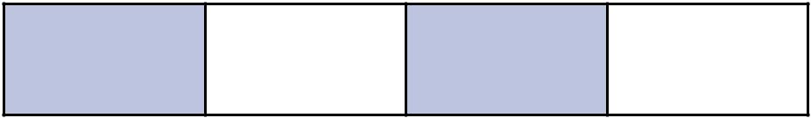
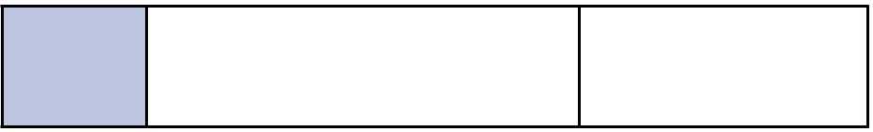
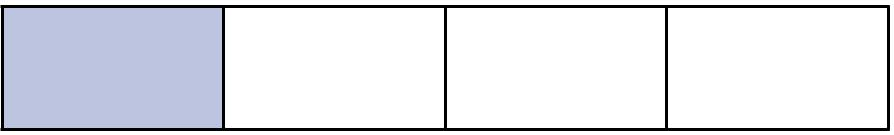
³

- Amy has a sheet of paper. She cuts the sheet into halves. How many pieces of paper does she have now?

- Abdul has some toy cars.
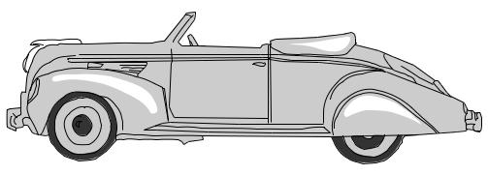
He gives half of them to Ben.
He has four toy cars left.
How many toy cars did Abdul start with?

- Draw lines to divide the rectangle into quarters. Use the dots to help you.
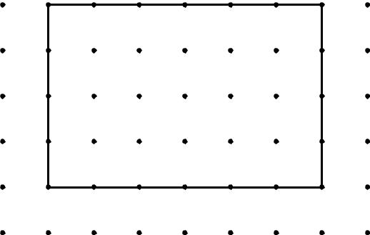

- Shade the fractions of the shapes.

Shade 1/2
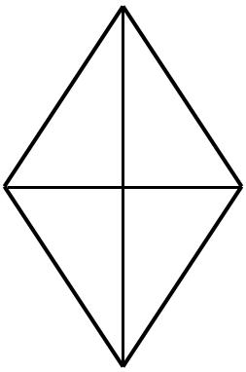
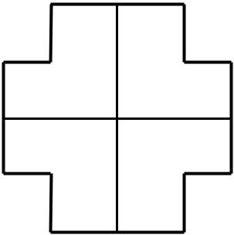

Shade 3/4
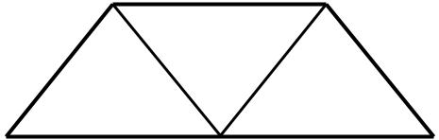

Shade 1/3

Measures
- Circle the shortest time.

70 minutes 10 minutes 45 minutes 1 hour

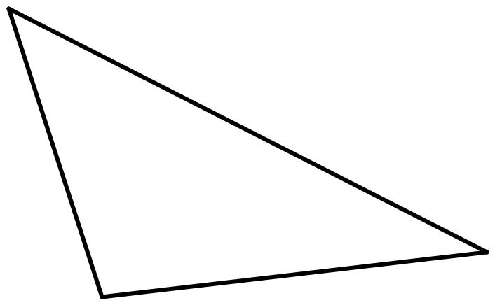
- Measure the longest line. Use a ruler.

- The strawberry weighs 24 grams.

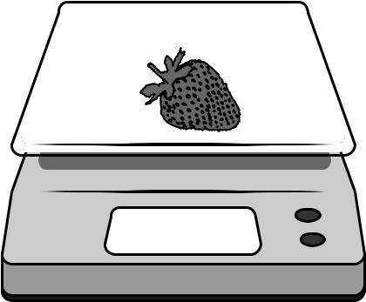

24 g

The strawberry and tomato together weigh 69 grams.
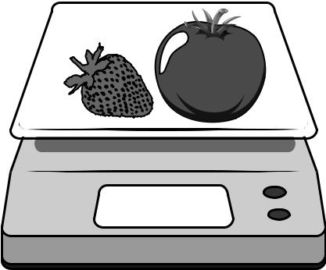

69 g

What does the tomato weigh?

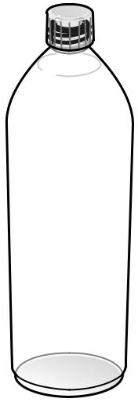
- Here is a bottle of water. What is the capacity of the bottle: two centimetres, two kilograms, two degrees Celsius or two litres?

2 cm 2 kg 2 °C 2 l

- Look at the picture of Sam and Ben in question 5. Sam’s arm is fifty centimetres long. Ben’s arm is forty centimetres long. How much longer is Sam’s arm than Ben’s arm?

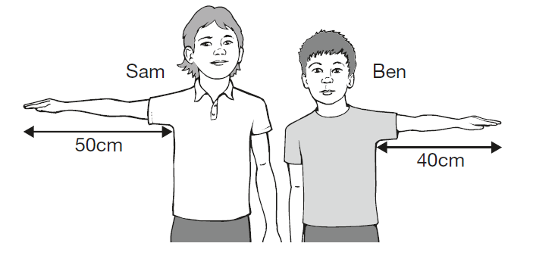

6

- Sort the glasses from least full to most full.
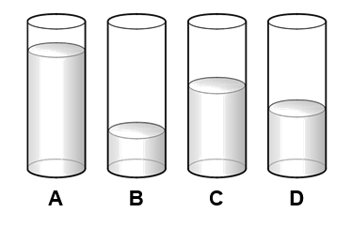

least full most full

- How much does the sugar weigh?

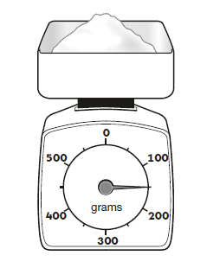

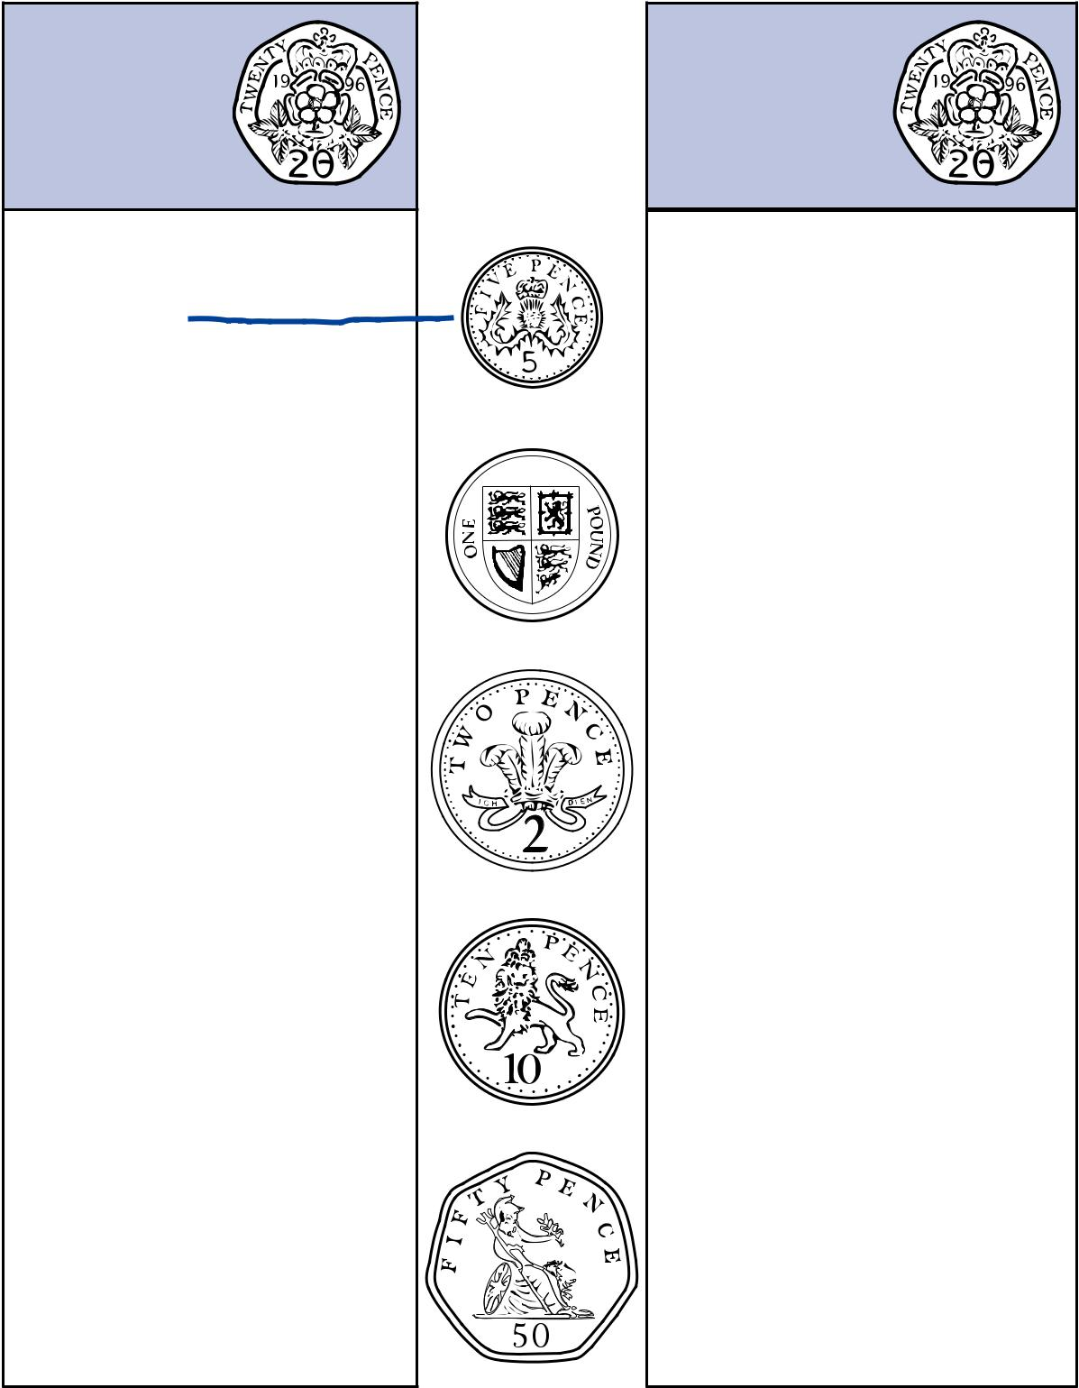
- Match each coin to the correct box. One has been done for you.

Less than | More than

- Tick the clock face that shows ten past twelve.
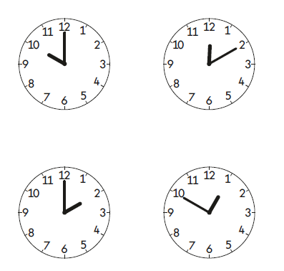

Shape
- Tick the pentagon.

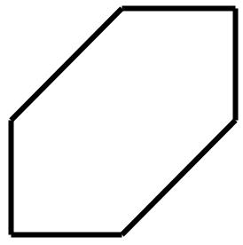
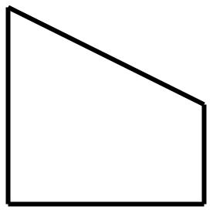

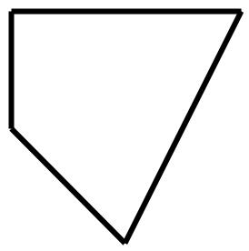
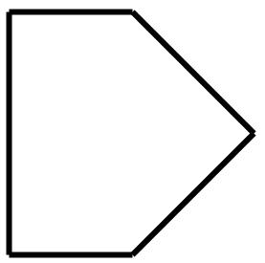

- Two shapes have more than 8 edges. Tick them.

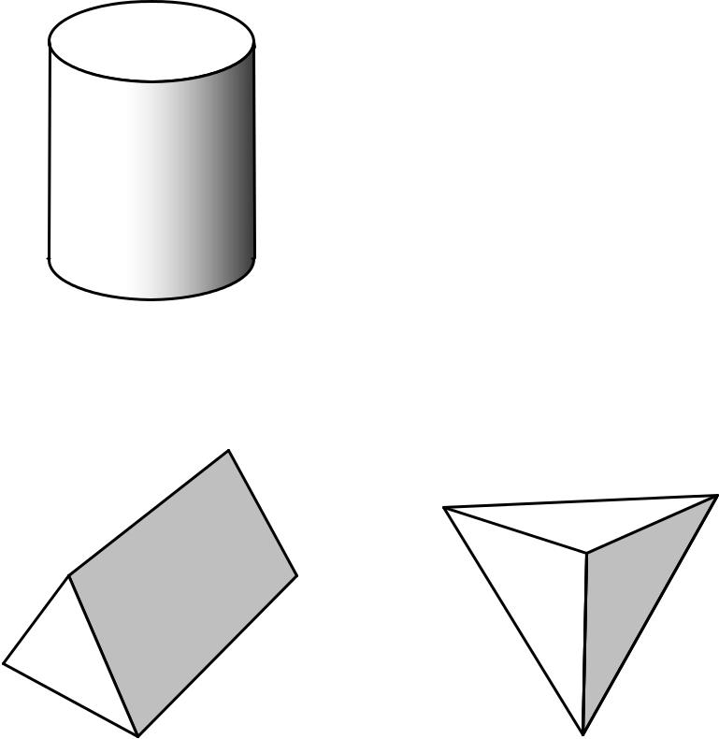
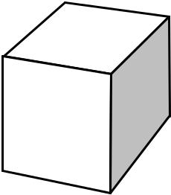

- Tick the two sentences that are correct.

Tick two.

A square has sides of equal length.

A square has curved sides.

A square has lines of symmetry.

A square has five sides.

- Which shape has exactly 5 faces? Write the letter.
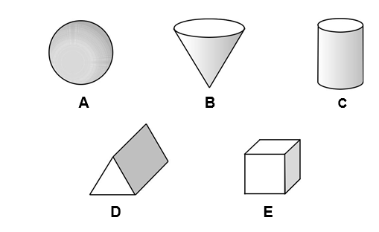

- Draw lines to match the shapes to their names.
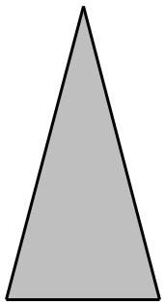

pentagon

triangle
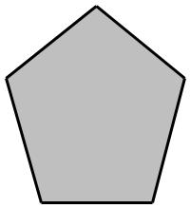

octagon

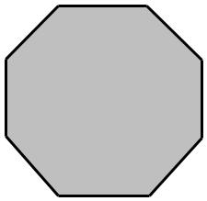

hexagon

Position and Direction
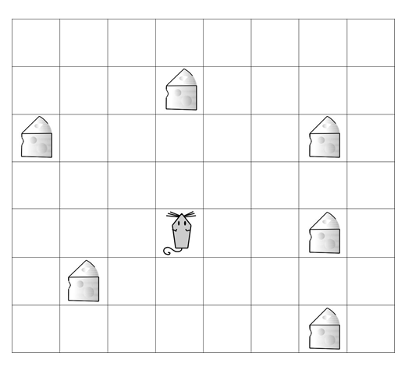
- Look at the mouse.
Ajay moves the mouse to a piece of cheese.
He moves the mouse two squares forward.
He then turns the mouse a quarter of a turn clockwise and moves it forward three squares.
Circle the piece of cheese the mouse lands on.

- This turtle is rotated clockwise.
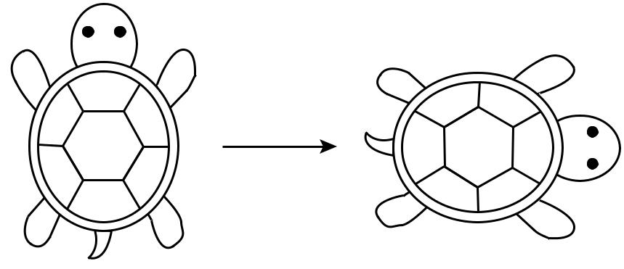

How much is the turtle rotated? Circle your answer.

quarter half three-quarter full
turn turn turn turn

Statistics
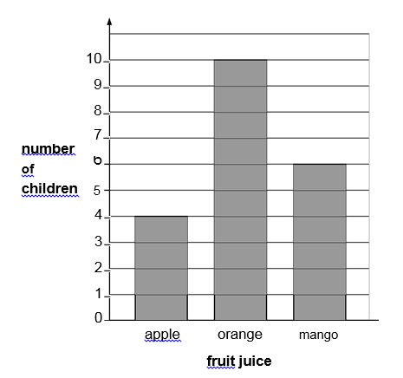
- 20 children choose their favourite fruit juice. The chart shows the results.

(a) How many more children choose orange than apple?

(b) Another boy joins the group. He chooses mango juice. Add this information to the chart.

- Ben makes a tally chart of his toys.

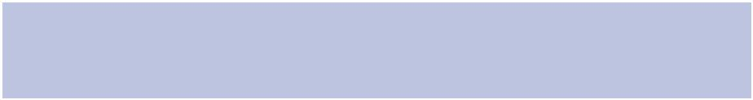
Toys in my box | Tally
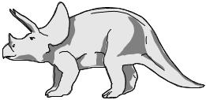
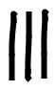
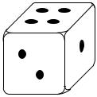
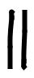
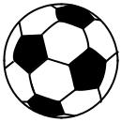
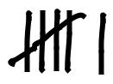
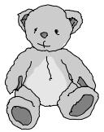
Tick one box below that shows all of Ben’s toys.


